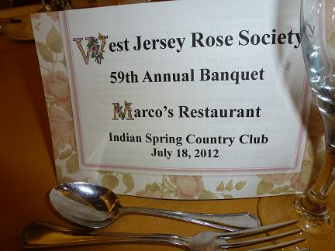
Our Annual Banquet is the WJRS “social event of the year”
On July 18, happy rose lovers, friends and families enjoyed each other’s company with a delicious meal at Marco’s Restaurant at the Indian Spring Country Club.
Everyone enthusiastically participated in our "Rosy Romance" story-telling game with some some amazingly creative, funny and occasionally odd answers. Bill Kozemchak, assisted by Brenna Bosch, were Solomon-like in their judging of the best story.
A round of applause to Cora Williams and her creative arrangers (Diane Fennimore, Iliana Okum, Sally Anne Schweitzer and Betty Simon) for their strikingly colorful floral centerpieces, and to Dee Bosch for preparing the trophies and for documenting the Banquet festivities.
Special thank you's to Michelle Ziemba for her calm efficiency in herding us through registration, to Frank Palise for offering his long arms to assist with the awarding of our "special prizes", to Terry Palise, our Mistress of Ceremonies, for keeping the rowdy crowd in order and for her moving opening and closing prayers, to Iliana Okum for her speedy Installation of Officers, and to Brenna Bosch and Rhea Bolar for presenting all the right awards to the right people.
Not only were the Rose Show trophies awarded (see list of winners), but everyone who attended won at least one fabulous door prize contributed by one of our generous donors (see below). We also had some wonderful Special Prizes including dinners, memberships, theater tickets, Phillies tickets and baskets of roses.
Congratulations to Iliana Okum, our ARS Bronze Medal honoree, to Brenna Bosch, our Rosarian of the Year, to Dee and Bill Bosch who received special certificates for outstanding contributions to our society, to our new Lifetime Member, Gus Banks, and to all our talented Rose Show winners.
See you next year!
June

