The Medal Of Honor Rose Garden at Beverly National Cemetery
Richard J. Myers , Consulting Rosarian

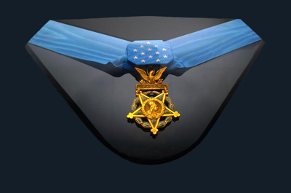

After tending to the Medal Of Honor Garden at Beverly National Cemetery with West Jersey Rose Society members, I felt the need to know why these Heroes were awarded the Nation’s highest honor, The Medal of Honor. There is a wealth of information available on the Internet concerning the Medal Of Honor and Beverly National Cemetery. Here is a little bit of the story.
The Medal of Honor is the highest award for valor in action against an enemy force which can be bestowed upon an individual serving in the Armed Services of the United States. Generally, it is presented to its recipient by the President of the United States of America in the name of Congress.
Beverly National Cemetery is located in Burlington County’s Edgewater Park, in the city of Beverly, New Jersey.
The original cemetery was only one acre, purchased from a local resident in 1863. The plot was located in the northwest corner of the town cemetery surrounded by a picket fence. Additional land was acquired in 1936, 1937, 1948, and 1951.
The cemetery was established to provide a burial site for veterans who died in one of two nearby hospitals. Of the original 147 Union soldiers buried at Beverly National Cemetery, only 10 are unknown. For much of its history, the cemetery handled relatively few interments. The number of interments grew dramatically, however, when space became unavailable at Philadelphia National Cemetery. Beverly National Cemetery was listed on the National Register of Historic Places in 1997.
In 1994, the World War II veterans in our society decided that the society should develop a garden to honor the memories of the veterans who were buried there. Led by Robert Schwarzkopf, Jack Conrad, Frank Rosati and their spouses; the society and cemetery officials selected an area where the Medal of Honor veterans were interred for the rose garden. Star Roses was contacted and they donated red and white rose bushes for the garden. The roses initially put into the garden were hybrid tea and floribunda roses. It has been a difficult task to maintain these roses and they were replaced with “Knockout” varieties. Star Roses donated the roses.

Medal of Honor Recipients:
Hospital Corpsman Third Class Edward C. Benfold, (Korean War) U.S. Navy. Korea, Sept. 5, 1952 (Section DS, Grave 12).
Sergeant First Class Nelson Vogel Brittin, (Korean War) U.S. Army, Company I, 19th Infantry Regiment. Yonggong-ni, Korea, March 7, 1951 (Section DS, Grave 2).
Private First Class John W. Dutko, (World War II) U.S. Army, 3rd Infantry Division. Near Ponte Rotto, Italy, May 23, 1944 (Section DS, Grave 1).
First Sergeant Bernard A. Strausbaugh, (Civil War) Company A, 3rd Maryland Infantry. Petersburg, VA, June 17, 1864 (Section 1, Grave 102).
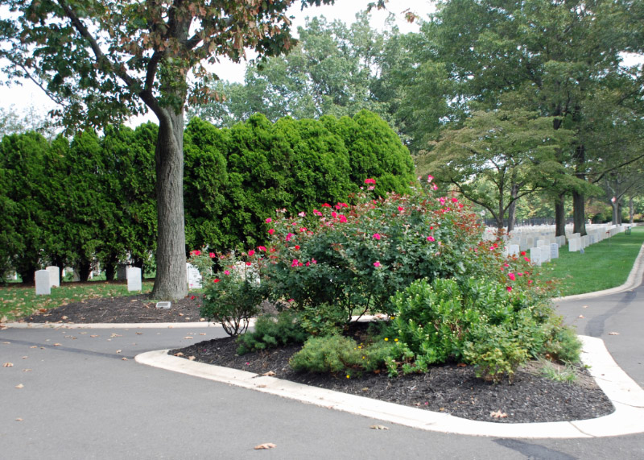
Photo by Gus Banks Photo by Gus Banks

Below are the Citations that documented the actions that resulted in the awarding of the Medal Of Honor to the Beverly National Cemetery recipients:

Hospital Corpsman Third Class
Edward C. Benfold, (Korean War) U.S. Navy. Korea, Sept. 5, 1952 (Section DS, Grave 12).
Born: 15 January 1931, Staten Island, N.Y.
Entered Service At: Philadelphia, PA.
Place / Date: Korea, 5 September 1952.
Citation:
For gallantry and intrepidity at the risk of his life above and beyond the call of duty while serving in operations against enemy aggressor forces. When his company was subjected to heavy artillery and mortar barrages, followed by a determined assault during the hours of darkness by an enemy force estimated at battalion strength, HC3c. Benfold resolutely moved from position to position in the face of intense hostile fire, treating the wounded and lending words of encouragement. Leaving the protection of his sheltered position to treat the wounded when the platoon area in which he was working was attacked from both the front and rear, he moved forward to an exposed ridge line where he observed 2 marines in a large crater. As he approached the 2 men to determine their condition, an enemy soldier threw 2 grenades into the crater while 2 other enemy charged the position. Picking up a grenade in each hand, HC3c Benfold leaped out of the crater and hurled himself against the on-rushing hostile soldiers, pushing the grenades against their chests and killing both the attackers. Mortally wounded while carrying out this heroic act, HC3c. Benfold, by his great personal valor and resolute spirit of self-sacrifice in the face of almost certain death, was directly responsible for saving the lives of his 2 comrades. His exceptional courage reflects the highest credit upon himself and enhances the finest traditions of the U.S. Naval Service. He gallantly gave his life for others.

Sergeant First Class Nelson Vogel Brittin, (Korean War) U.S. Army, Company I, 19th Infantry Regiment. Yonggong-ni, Korea, March 7, 1951
(Section DS, Grave 2).
Born: Audubon, N.J.
Entered Service At: Audubon, N.J.
Place/Date: Vicinity of Yonggong-ni, Korea, 7 March 1951.
Citation:
SFC. Brittin, a member of Company I, distinguished himself by conspicuous gallantry and intrepidity above and beyond the call of duty in action. Volunteering to lead his squad up a hill, with meager cover against murderous fire from the enemy, he ordered his squad to give him support and, in the face of withering fire and bursting shells, he tossed a grenade at the nearest enemy position. On returning to his squad, he was knocked down and wounded by an enemy grenade. Refusing medical attention, he replenished his supply of grenades and returned, hurling grenades into hostile positions and shooting the enemy as they fled. When his weapon jammed, he leaped without hesitation into a foxhole and killed the occupants with his bayonet and the butt of his rifle. He continued to wipe out foxholes and, noting that his squad had been pinned down, he rushed to the rear of a machine gun position, threw a grenade into the nest, and ran around to its front, where he killed all 3 occupants with his rifle. Less than 100 yards up the hill, his squad again came under vicious fire from another camouflaged, sandbagged, machine gun nest well-flanked by supporting riflemen. Sfc. Brittin again charged this new position in an aggressive endeavor to silence this remaining obstacle and ran direct into a burst of automatic fire which killed him instantly. In his sustained and driving action, he had killed 20 enemy soldiers and destroyed 4 automatic weapons. The conspicuous courage, consummate valor, and noble self-sacrifice displayed by Sfc. Brittin enabled his inspired company to attain its objective and reflect the highest glory on himself and the heroic traditions of the military service.

Private First Class John W. Dutko,
(World War II) U.S. Army, 3rd Infantry Division. Near Ponte Rotto, Italy, May 23, 1944
(Section DS, Grave 1).
Born: Dilltown, PA.
Entered Service At: Riverside, N.J.
Place / Date: Near Ponte Rotto, Italy, 23 May 1944.
Citation:
For conspicuous gallantry and intrepidity at risk of life above and beyond the call of duty on 23 May 1944, near Ponte Rotto, Italy. Pfc. Dutko left the cover of an abandoned enemy trench at the height of an artillery concentration in a single-handed attack upon 3 machineguns and an 88mm. mobile gun. Despite the intense fire of these 4 weapons which were aimed directly at him, Pfc. Dutko ran 10.0 yards through the impact area, paused momentarily in a shell crater, and then continued his 1-man assault. Although machinegun bullets kicked up the dirt at his heels, and 88mm. shells exploded within 30 yards of him, Pfc. Dutko nevertheless made his way to a point within 30 yards of the first enemy machinegun and killed both gunners with a hand grenade. Although the second machinegun wounded him, knocking him to the ground, Pfc. Dutko regained his feet and advanced on the 88mm. gun, firing his Browning automatic rifle from the hip. When he came within 10 yards of this weapon he killed its 5-man crew with 1 long burst of fire. Wheeling on the machinegun which had wounded him, Pfc. Dutko killed the gunner and his assistant. The third German machinegun fired on Pfc. Dutko from a position 20 yards distant wounding him a second time as he proceeded toward the enemy weapon in a half run. He killed both members of its crew with a single burst from his Browning automatic rifle, continued toward the gun and died, his body falling across the dead German crew.

First Sergeant Bernard A. Strausbaugh, (Civil War) Company A, 3rd Maryland Infantry. Petersburg, VA., June 17, 1864 (Section 1, Grave 102).
Born Adams County, PA.
Entered Service At: Warfordsburg, PA.
Place / Date: At Petersburg, VA, 17 June 1864.
Citation:
Recaptured the colors of 2d Pennsylvania Provisional Artillery.
After learning the stories of these “Heroes,” I feel honored to be given the privilege to tend to their final resting place. Volunteer this year to tend to the Honor Garden at Beverly National Cemetery, and think about the sacrifices these brave warriors made for us while you are working in the rose garden. The cemetery is the final resting place for many veterans of all the services and each one of them is a “Hero.”

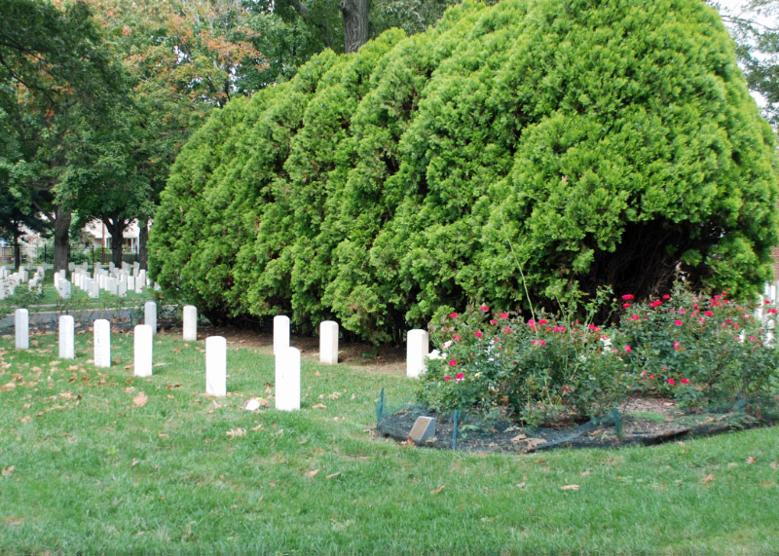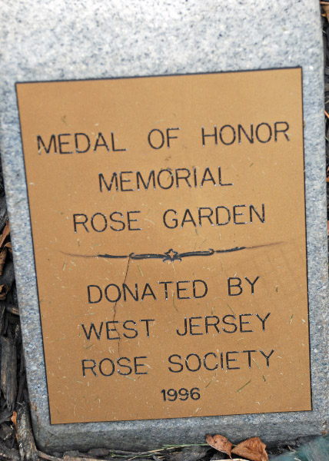
Photos by Gus Banks

