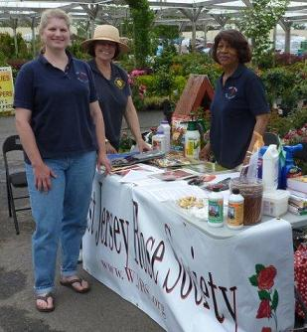
Brenna, June and Cora at Magnolia Garden Village
Rose Days!
As part of our society’s charter, we love to share our joy and knowledge about roses. This spring, members of WJRS visited several of our local Good Sense garden centers for “Rose Days”. We helped shoppers learn about roses and introduced our society to interested visitors.
Thank you to our enthusiastic members: Brenna Bosch, Diane Fennimore, June Hament, Laura Livingston, Betty Simon and Cora Williams
And a big Thank You to our local garden centers that do so much to support the WJRS:
Haines Farm and Garden Magnolia Garden Village
www.hainesfarmandgarden.com www.magnoliagardenvillage.com
Laurel Oak Garden Center Spotts Garden Center
www.LaurelOakGardenCenter.com (609) 654-4499

